|  |  |  |
| --- | --- | --- |
| **Group No.** | **Group Members (Regd. No.)** | **Project Title** |
|  | JATIN KUMAR PAL (2041016018) | Efficient Home Management System using Raspberry Pi Pico W and Blynk 2.0 |
| SOURAV KERKETTA (2041011016) |

# Introduction

The Efficient Home Management System utilizes Raspberry Pi Pico W and Blynk 2.0 to streamline household operations. By integrating the power of Raspberry Pi Pico W, a versatile microcontroller, withtheuser-friendlyBlynk2.0platform, this system enables remote monitoring and control of various home devices. With Blynk 2.0's intuitive interface, users can seamlessly interact with their smart home components, such as lighting, temperature control, and security systems, all from a mobile device. The Raspberry Pi Pico W serves as the central hub, facilitating communication between Blynk2.0 and connected devices. This solution promotes energy efficiency, as users can remotely manage and optimize device usage. Moreover, it enhances security by allowing real-time monitoring of surveillance cameras and access control systems. The lightweight and cost-effective nature of the Raspberry Pi Pico W, coupled with Blynk 2.0's user-friendly interface, make this Efficient Home Management System an accessible and effective solution for modern households.

# Problem identification and Problem Formulation: Problem Identification:

* + **Inefficient Device Management:** Many households lack a centralized system to efficiently control and monitor various devices, leading to energy wastage and inconvenience.
  + **Limited Remote Accessibility:** Traditional home management systems often lack effective remote access, restricting users from monitoring and controlling devices when away.
  + **Complexity in Integration:** Integrating diverse smart phone devices can be challenging, requiring a user-friendly solution to ensure seamless communication and operation.
  + **Security Concerns:** The need for robust security measures to protect smart home systems from unauthorized access and potential breaches.

# Problem Formulation:

* + **Centralized Device Control:** Develop a system using Raspberry Pi Pico W and Blynk
  + **Enhanced Remote Accessibility:** Implement a solution that provides users with secure and user-friendly remote access to their home management system, ensuring they can monitor and control devices from anywhere.
  + **Simplified Integration:** Formulate a straightforward integration process for diverse smart home devices, ensuring compatibility and ease of use for a wide range of users.
  + **Security Measures:** Integrate robust security features within the system, including encrypted communication and user authentication, to safeguard the smart home environment from potential threats.

By addressing these problem areas through the development of an Efficient Home Management System using Raspberry Pi Pico W and Blynk 2.0, the aim is to create a user- friendly, secure, and accessible solution that optimizes device management in modern household.

# Objective of the Project:

The primary objectives of the Efficient Home Management System using Raspberry Pi Pico Wand Blynk 2.0 include:

* + **Centralized Control:** Provide users with a centralized platform for efficient control and monitoring of various smart home devices, promoting convenience and ease of use.
  + **Remote Accessibility:** Enable users to remotely access and manage their home devices through the Blynk 2.0 platform, enhancing flexibility and control even when away from home.
  + **Energy Efficiency:** Implement features that allow users to optimize energy usage by scheduling and monitoring devices, contributing to a more sustainable and cost-effective home environment.
  + **User-Friendly Interface:** Develop an intuitive and user-friendly interface through Blynk 2.0, ensuring that both tech-savvy and non-technical users can easily interact with and customize their smart home settings.
  + **Integration Compatibility:** Ensure seamless integration with a variety of smart home devices, promoting versatility and eliminating compatibility issues.
  + **Security:** Implement robust security measures, including encrypted communication and user authentication, to safeguard the system from unauthorized access and potential security threats.
  + **Scalability:** Design the system to be scalable, allowing users to expand and integrate additional devices or functionalities as needed, ensuring long-term relevance and adaptability.

By achieving these objectives, the Efficient Home Management System aims to enhance the overall home automation experience, providing users with a reliable, secure, and user-friendly solution for managing their smart home ecosystem.

1. **Block Diagram of the Project: (**Diagram of a system in which the principal parts or functions are represented by blocks connected by lines that show the relationships of the blocks**)**

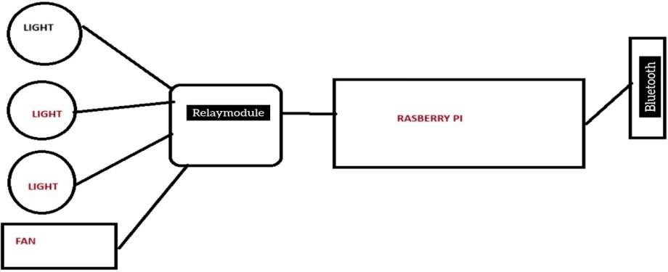

**Fig1:** Block Diagram

# Circuit Diagram of the Project:

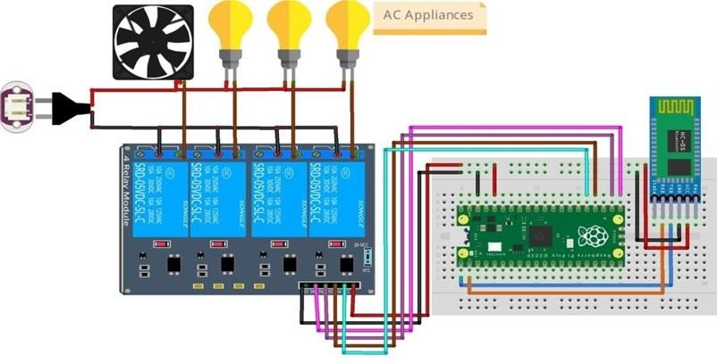

**Fig 2:** Circuit Diagram

# Components/Items Required:

**Table 1:** Component required

|  |  |  |  |
| --- | --- | --- | --- |
| **Sl. No.** | **Name of the Components** | **Specification** | **Quantity** |
| **1** | **Raspberry Pi Pico W** | **125 MHz** | **1** |
| **2** | **Relay Module** | **4 channels** | 1 |
| **3** | **Bluetooth Module** | **HC05** | 1 |
| **4** | **Breadboard** | **840points** | 1 |
| **5** | **Female plug** | **2 pins** | 60 |
| **6** | **Plug** | **2 pins** | 10 |
| **7** | **Wire** |  | N. A |

# Full Signature of Group members: 1.

**Signature of Corresponding Faculty**

**2.**